**CS365 Operating System**

**Lab 3**

**Part I Producer and consumer (multithread)**

Implement the code from Figures 4.13, 4.14, 4.15

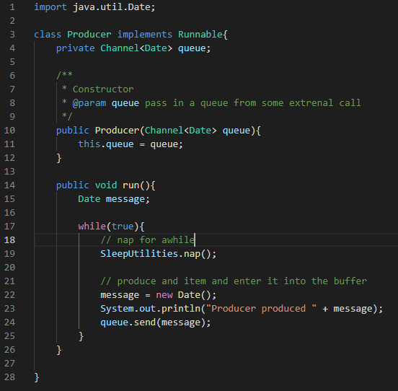

Figure 3: Next I recreated the Producer class which gets the queue and adds a date message to the queue thus “producing” them.

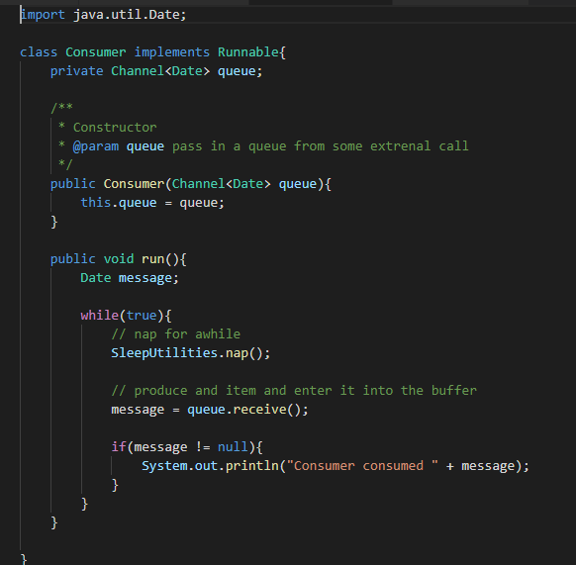

Figure 2: The next step was to create the Consumer class that gets the queue and receives messages and there by “consuming” them.

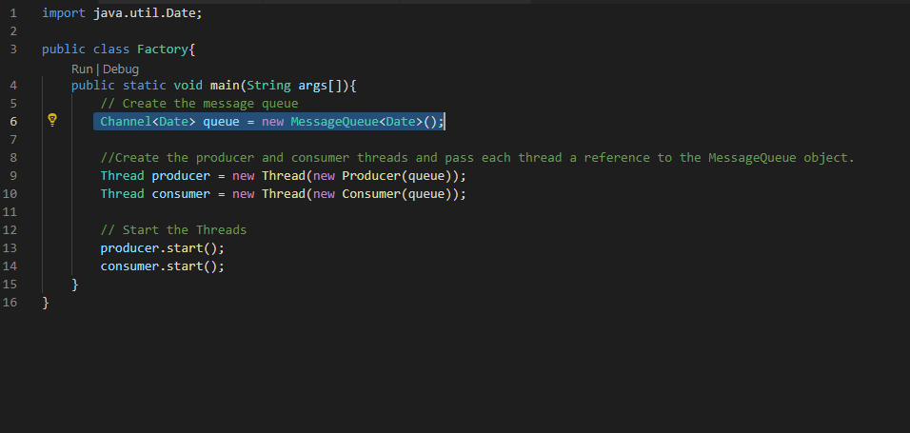

Figure 1: First Step was to create the Factory class and setting it up to create a producer and consumer

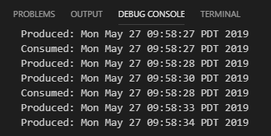

Figure 4: Output of the queue version

**Part II Producer and consumer (semaphore)**

Implement the code from Figures 6.9 – 6.14

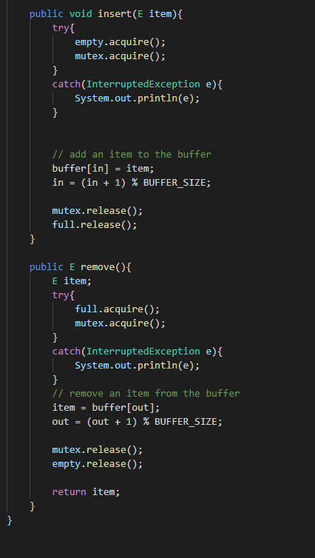

Figure 7: BoundedBuffer 2/2 - implementation of the insert and remove methods from the interface.

First was the creation of the BoundedBuffer class.

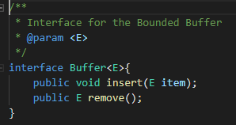

Figure 5: Created an interface class to be used in the bounded buffer.

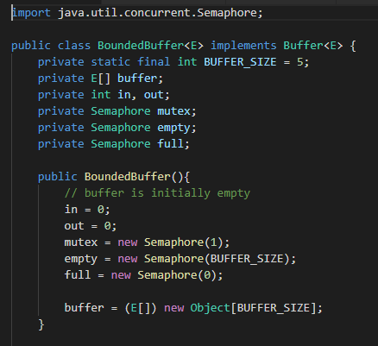

Figure 6: BoundedBuffer 1/2 - Class constructor initializing the buffer with in, out, mutex, empty, and full states.

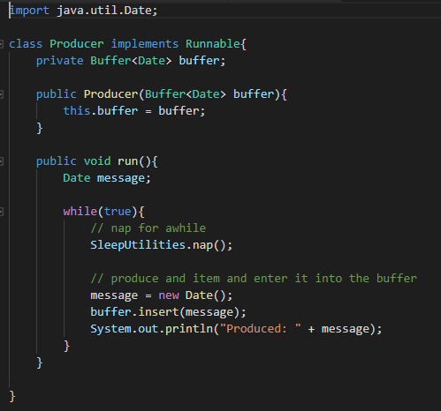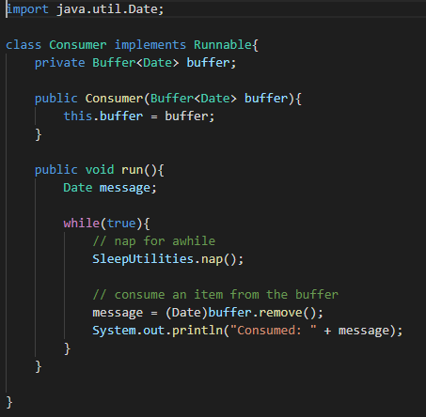

Figure 9: Updated the consumer to use the buffer and remove() method for "consuming" items

Figure 10: Updated the producer to use the buffer and insert() method for "producing" items.

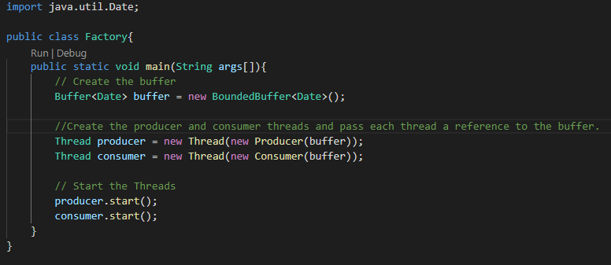

Figure 8: Updated factory to use the new bounded buffer class

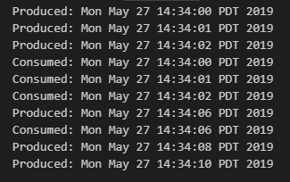

Figure 11: Output of the Bounded Buffer version.